# Industrial Internship Report on

**”Project Name”**

# Prepared by

**D. Yashwanth reddy**

|  |
| --- |
| *Executive Summary* |
| This report provides details of the Industrial Internship provided by upskill Campus and The IoT Academy in collaboration with Industrial Partner UniConverge Technologies Pvt Ltd (UCT).  This internship was focused on a project/problem statement provided by UCT. We had to finish the project  including the report in 6 weeks’ time.  My project was (Tell about ur Project)  This internship gave me a very good opportunity to get exposure to Industrial problems and design/implement solution for that. It was an overall great experience to have this internship. |

**TABLE OF CONTENTS**

1. Preface 3
2. Introduction 4
   1. About UniConverge Technologies Pvt Ltd 4
   2. About upskill Campus 8
   3. Objective 9
   4. Reference 9
   5. Glossary 10
3. Problem Statement 11
4. Existing and Proposed solution 12
5. Proposed Design/ Model 13
   1. High Level Diagram (if applicable) 13
   2. Low Level Diagram (if applicable) 13
   3. Interfaces (if applicable) 13
6. Performance Test 14
   1. Test Plan/ Test Cases 14
   2. Test Procedure 14
   3. Performance Outcome 14
7. My learnings 15
8. Future work scope 16

### Preface

Summary of the Whole 6 Weeks’ Work:

Over the next six weeks, you will immerse yourself in the fields of data science and machine learning. You will acquire essential skills, from data collection and preprocessing to building predictive models, and learn how to extract valuable insights from data. Throughout this journey, you will engage in hands-on projects and real-world applications, culminating in a comprehensive understanding of data science and machine learning.

**The Need for Relevant Internship in Career Development:

In today’s fast-paced and data-driven world, the importance of relevant internships cannot be overstated. These experiences provide a bridge between academic learning and practical application, offering you the chance to apply your knowledge in real-world scenarios. They also allow you to network with professionals, gain industry insights, and build a portfolio that can significantly enhance your career prospects.

*Brief About Your Project/Problem Statement:

During this internship, you will work on a real-world project designed to tackle a specific data science challenge. You will be presented with a problem statement that requires data analysis, modeling, and machine learning solutions. This hands-on experience will provide you with a tangible example of how data science is applied to solve complex problems..

How the Program Was Planned:

This internship program was meticulously planned to offer a structured and comprehensive learning experience. Each week is carefully designed to build on the previous one, allowing you to gradually

expand your skills and knowledge. You’ll receive guidance from experienced mentors and experts who are dedicated to your success.

In the next six weeks, you’ll embark on a transformative journey that will equip you with the skills and confidence to excel in the dynamic and exciting fields of data science and machine learning. We encourage you to fully engage with the material, seek support when needed, and make the most of this

invaluable opportunity for your personal and professional growth. Let’s begin this journey together and

embrace the world of data science and machine learning.

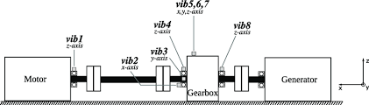

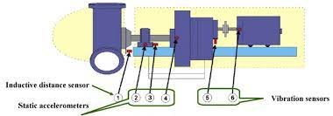

### Introduction

#### About UniConverge Technologies Pvt Ltd

A company established in 2013 and working in Digital Transformation domain and providing Industrial solutions with prime focus on sustainability and RoI.

For developing its products and solutions it is leveraging various **Cutting Edge Technologies e.g. Internet of Things (IoT), Cyber Security, Cloud computing (AWS, Azure), Machine Learning, Communication Technologies (4G/5G/LoRaWAN), Java Full Stack, Python, Front end** etc.

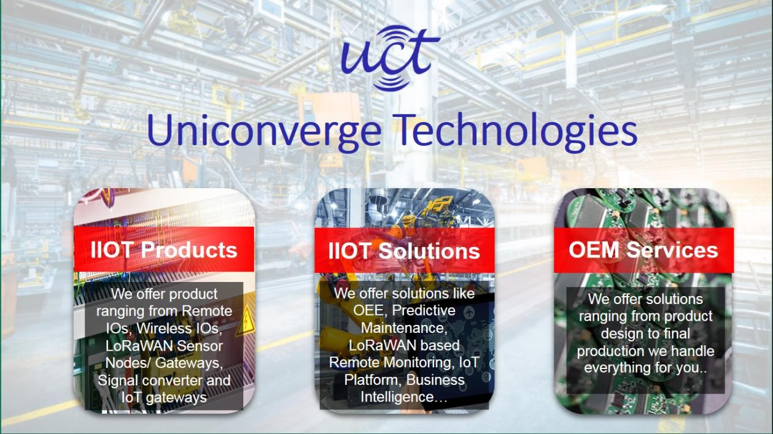

# UCT IoT Platform ( )

**UCT Insight** is an IOT platform designed for quick deployment of IOT applications on the same time providing valuable “insight” for your process/business. It has been built in Java for backend and ReactJS for Front end. It has support for MySQL and various NoSql Databases.

* It enables device connectivity via industry standard IoT protocols - MQTT, CoAP, HTTP, Modbus TCP, OPC UA
* It supports both cloud and on-premises deployments.

It has features to

* Build Your own dashboard
* Analytics and Reporting
* Alert and Notification
* Integration with third party application(Power BI, SAP, ERP)
* Rule Engine

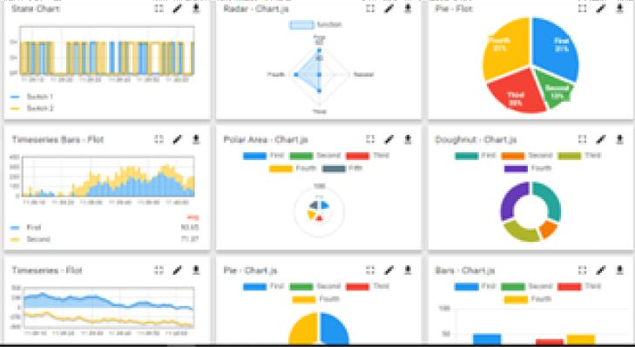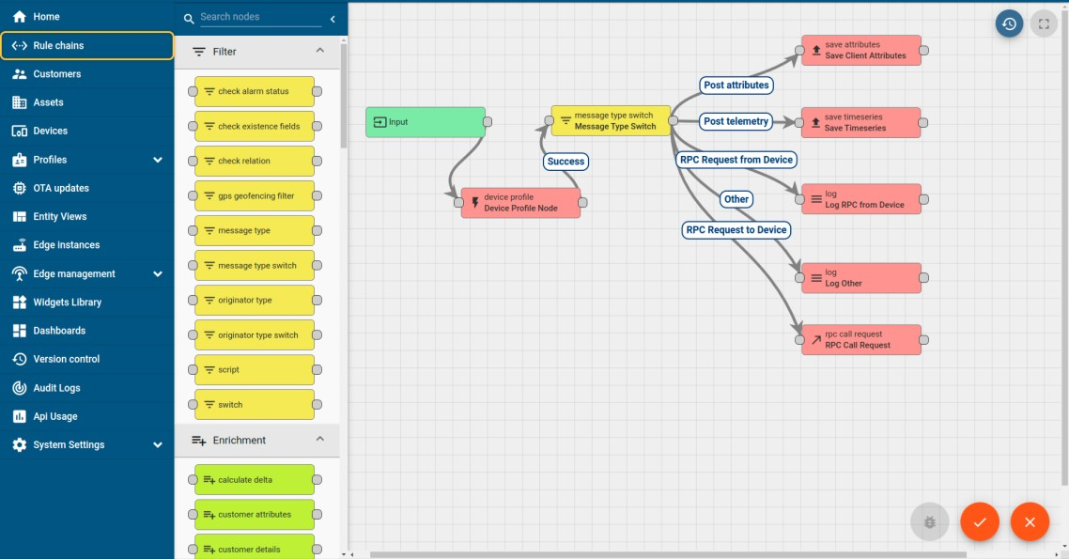

# Smart Factory Platform ( )

Factory watch is a platform for smart factory needs. It provides Users/ Factory

* with a scalable solution for their Production and asset monitoring
* OEE and predictive maintenance solution scaling up to digital twin for your assets.
* to unleased the true potential of the data that their machines are generating and helps to identify the KPIs and also improve them.
* A modular architecture that allows users to choose the service that they what to start and then can scale to more complex solutions as per their demands.

Its unique SaaS model helps users to save time, cost and money.

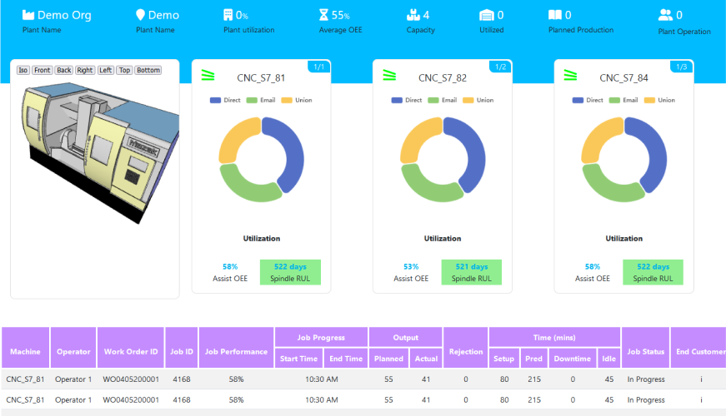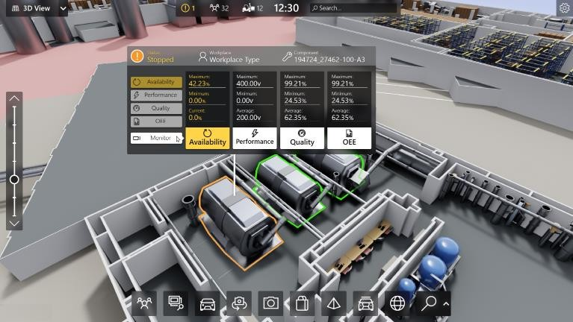

## What is LoRaWAN? - Yeastar Workplace Helpbased Solution

UCT is one of the early adopters of LoRAWAN teschnology and providing solution in Agritech, Smart cities, Industrial Monitoring, Smart Street Light, Smart Water/ Gas/ Electricity metering solutions etc.

## Predictive Maintenance

UCT is providing Industrial Machine health monitoring and Predictive maintenance solution leveraging Embedded system, Industrial IoT and Machine Learning Technologies by finding Remaining useful life time of various Machines used in production process.

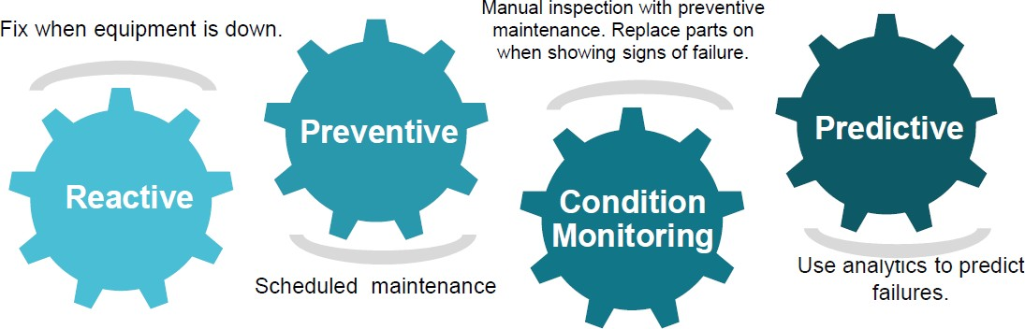

#### About upskill Campus (USC)

upskill Campus along with The IoT Academy and in association with Uniconverge technologies has facilitated the smooth execution of the complete internship process.

USC is a career development platform that delivers **personalized executive coaching** in a more affordable, scalable and measurable way.

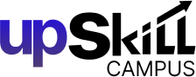

Seeing need of upskilling in self paced manner along-with additional support services e.g. Internship, projects,

interaction with Industry

upSkill Campus aiming to upskill 1 million learners in next 5 year

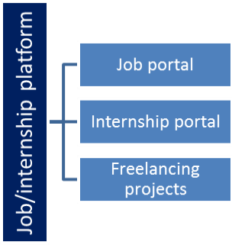experts, Career growth Services

<https://www.upskillcampus.com/>

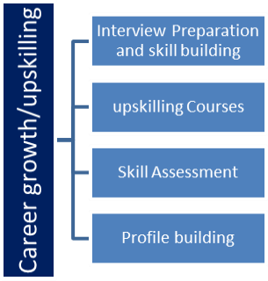 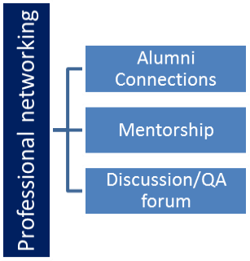 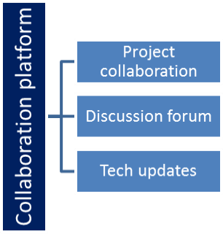

#### The IoT Academy

The IoT academy is EdTech Division of UCT that is running long executive certification programs in collaboration with EICT Academy, IITK, IITR and IITG in multiple domains.

#### Objectives of this Internship program

The objective for this internship program was to

☛ get practical experience of working in the industry.

☛ to solve real world problems.

☛ to have improved job prospects.

☛ to have Improved understanding of our field and its applications.

☛ to have Personal growth like better communication and problem solving.

#### Reference

[1] https:[//w](http://www.upskillcampus.com/)ww[.upskillcampus.com/](http://www.upskillcampus.com/)

* 1. **Glossary**

|  |  |
| --- | --- |
| Terms | Acronym |
|  |  |
|  |  |
|  |  |
|  |  |
|  |  |

### Problem Statement

Developing an efficient predictive maintenance system for gearboxes using vibration sensors is crucial to detect early signs of mechanical issues and prevent costly breakdowns in industrial settings. The primary challenges include robust data collection, complex data analysis, and meeting performance constraints while maintaining high accuracy. The objective is to provide a cost-effective solution that reduces downtime, minimizes maintenance costs, and enhances operational reliability, ultimately ensuring the smooth functioning of industries.

### Existing and Proposed solution

Existing Solutions:

Existing solutions for predictive maintenance in gearbox systems often rely on vibration analysis, but they may have limitations. Some solutions use rule-based methods, which lack adaptability to changing conditions. Others employ basic anomaly detection algorithms, which might generate false alarms or miss early signs of issues. Traditional methods often require manual inspection, which is time-consuming and may not be cost-effective in the long term.

Proposed Solution:

Our proposed solution leverages advanced machine learning algorithms for predictive maintenance with vibration sensors. We employ deep learning and data-driven models to analyze vibration data, enabling accurate and early detection of gearbox issues. This approach is adaptable to varying conditions and minimizes false alarms.

Value Addition:

Our solution adds value by:

* Enhancing accuracy and reliability through advanced data analysis techniques.
* Reducing downtime and maintenance costs by detecting issues early.
* Providing a cost-effective, automated, and scalable system that can be applied to various industrial gearboxes.
* Improving safety by preventing unexpected breakdowns.
* Offering a user-friendly interface for maintenance teams to make informed decisions.

#### Code submission (Github link)

https://github.com/Miller8765/test-code

* 1. **Report submission (Github link) :** first make placeholder, copy the link.

### Proposed Design/ Model

Predictive maintenance of gearboxes using vibration sensors is a valuable technique in industrial settings. Vibration sensors are used to continuously monitor the vibrations produced by the gearbox during its operation. By analyzing the vibration data, maintenance teams can detect early signs of mechanical issues, such as misalignment, imbalance, bearing wear, and gear tooth damage. This enables maintenance to be performed proactively, reducing the risk of unexpected breakdowns and minimizing downtime.

Key steps in implementing predictive maintenance with vibration sensors include data collection, signal processing, anomaly detection, and condition monitoring. Machine learning algorithms can be applied to analyze the vibration data and predict when maintenance is needed based on deviations from normal operating conditions.

The benefits of this approach include cost savings, increased equipment reliability, and improved safety by preventing catastrophic failures. However, successful implementation requires expertise in sensor placement, data analysis, and domain knowledge about gearbox behavior.

#### Interfaces (if applicable)

Update with Block Diagrams, Data flow, protocols, FLOW Charts, State Machines, Memory Buffer Management.

### Performance Test

Performance testing is a crucial aspect of any real-world project, including predictive maintenance with

vibration sensors for gearboxes. Here’s how you can address this in the context of your project:

1. Identify Constraints: Start by identifying the performance constraints relevant to your system. These could include memory usage, processing speed (MIPS), operations per second, accuracy, durability, and power consumption.
2. Design Considerations: Explain how you incorporated these constraints

into your project’s design. Discuss the design choices you made to optimize for the identified constraints. This may involve selecting specific components, algorithms, or configurations.

1. Testing and Results: Share the results of performance tests conducted on your system. Discuss how well your design performed within the

identified constraints. If certain constraints couldn’t be tested directly,

explain why and what potential impacts they could have on your design.

1. Impact Assessment: Analyze how constraints, when not met, could affect the real-world performance and usability of your system. For example, if your system exceeds its power consumption constraints, it could lead to increased operating costs or reduced system lifespan.
2. Recommendations: Offer recommendations on how to handle constraints that couldn’t be met or areas for improvement. Suggest potential solutions or modifications to mitigate the impact of unmet constraints. This might involve revisiting the design, optimizing algorithms, or selecting alternative components.

#### Performance Outcome

The performance outcome in the context of predictive maintenance using vibration sensors for gearboxes typically focuses on how well the system operates in real-world conditions and whether it meets the specified objectives and constraints. Key aspects of performance outcomes include:

* 1. **Accuracy:** Evaluate how accurately the system detects and predicts potential faults in the gearbox based on vibration data. This is a crucial aspect of its performance, as false positives or false negatives can impact maintenance decisions.
  2. **Reliability:** Assess the system’s reliability in terms of its ability to consistently detect and predict issues. A reliable system should provide consistent results over time.
  3. **Efficiency:** Measure the system’s efficiency in terms of its computational and resource usage. This can include evaluating its processing speed, memory consumption, and power usage.
  4. **Durability:** Consider the system’s durability

over extended periods of operation. It should

maintain its performance and accuracy over time, even in challenging industrial environments.

1. **Response Time:** Evaluate how quickly the system responds to anomalies or potential issues in the gearbox. A fast response time is crucial for proactive maintenance.
2. **False Positive and False Negative Rates:** Analyze the rate of false alarms (false positives) and missed detections (false negatives). Striking the right balance is important to avoid unnecessary maintenance or overlooking critical issues.
3. **Scalability:** Assess the system’s ability to scale and handle data from multiple gearboxes simultaneously. This is important for industrial applications with numerous machines.
4. **Cost-effectiveness:** Consider the cost-effectiveness of the system. Does it provide a good return on investment in terms of preventing expensive gearbox failures and downtime?
5. **User-Friendly Interface:** Evaluate the usability and user-friendliness of the system’s interface. Maintenance teams should be able to understand and interpret the results easily.
6. **Maintenance Impact:** Measure how the system’s predictions and recommendations impact the maintenance process. Does it help reduce downtime and maintenance costs?
7. **Real-world Testing:** Assess the system’s performance under real- world conditions, including variations in operating loads, temperatures, and other factors that can affect gearbox behavior.

### My learnings

In this 6-week internship in data science and machine learning, I embarked on a transformative journey, starting with the fundamentals of data collection and analysis, progressing to exploratory data analysis, statistical inference, and the application of machine learning techniques. By the end of this program, I have been equipped with the knowledge and skills to tackle real-world data challenges, build predictive models, and extract valuable insights. This experience will not only enhance my understanding of data science but also serve as a crucial stepping stone in my career development, offering the practical skills and experience that employers value in today’s data-driven world.

### Future work scope

As I look ahead, I see an exciting and promising future in the field of data science and machine learning. The skills and knowledge I’ve gained during this internship have ignited my passion for working with data and leveraging it to make informed decisions. I envision myself contributing to cutting-edge projects, solving complex problems, and delivering meaningful insights using data-driven approaches. Whether it’s in academia, industry, or research, I’m eager to be at the forefront of technological advancements, pushing the boundaries of what’s possible in the ever-evolving landscape of data science. My journey has just begun, and I’m ready to embrace the endless opportunities that await in this dynamic and rewarding field.